Date:

Payer Company Name
Street/Building Address
City, State ZIP

ATTN: Contact Name/ Contact Title

Re: Letter of RYTARY Medical Necessity for Plan Member Name

Plan member information:
Name: First and Last Name
Date of Birth: MM/DD/YYYY
ID Number: Insurance ID Number
Group Number: Insurance Group Number

Dear Sir or Madam:

This letter is to explain the rationale for my prescription of carbidopa and levodopa extended- release capsules (RYTARY®) for patient name. This individual suffers from Parkinson’s disease (PD) and is experiencing motor fluctuations on his/her current immediate-release carbidopa/levodopa regimen. RYTARY is FDA approved to treat PD and has proven efficacy in patients experiencing motor fluctuations.^{1,2}
While levodopa has been shown to improve motor function and quality of life and is widely recognized as an appropriate initial treatment for PD, the drug is not a panacea. Studies have shown that motor fluctuations are common in patients taking immediate-release carbidopa/levodopa. In a paper by the Parkinson Study Group, 16% to 30% of patients reported wearing off, even in early PD treated with levodopa for less than a year.³ A careful review of the literature performed by Ahlskog and Muenter in 2001 determined that after 4 to 6 years of levodopa therapy, the likelihood of a patient with PD experiencing motor fluctuations was 40%.⁴ A formulation of carbidopa/levodopa with a longer plasma concentration would be expected to improve this problem.
RYTARY is an extended-release form of carbidopa/levodopa. As shown in Figure 1, it is proven that RYTARY sustains levodopa levels longer than the other carbidopa/levodopa treatments.⁵ These include Sinemet® (immediate-release carbidopa/levodopa), Sinemet® CR (controlled-release carbidopa/levodopa), and Stalevo® (carbidopa/levodopa/entacapone).⁶⁻⁸
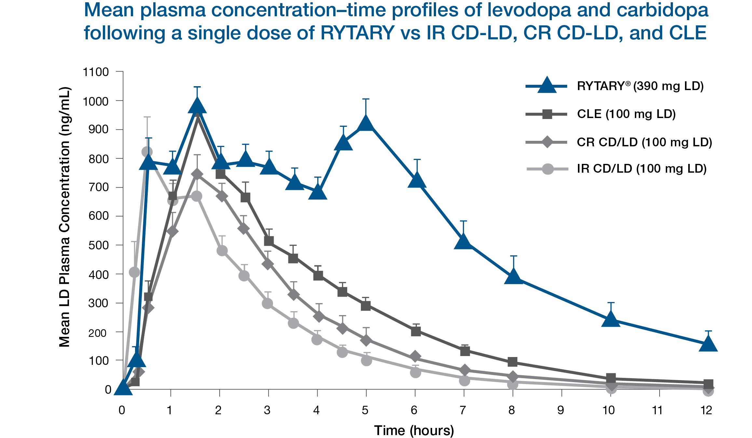

A randomized Phase 3 trial compared the efficacy of RYTARY with immediate-release carbidopa/levodopa in patients with PD who experienced motor fluctuations.² The study was performed in 68 centers in North America and Europe and evaluated 393 subjects allocated in a double-blind fashion to treatment with RYTARY or immediate-release carbidopa/levodopa. All patients were first optimized on immediate-release carbidopa/levodopa and were then converted in open-label fashion to an optimized dose and dosing regimen of RYTARY that was determined by individual dose titration. At that point, subjects were randomized to receive either continued treatment with the optimized dose of immediate-release carbidopa/levodopa or they were switched (in double-blind, double-dummy fashion) to their previously determined optimal dose of RYTARY. From a baseline level of about 6 hours per day of “off” time, the immediate-release carbidopa/levodopa group experienced about a 1-hour reduction of “off” time while the RYTARY group experienced an “off” time reduction of 2.2 hours. Accordingly, treatment with RYTARY produced twice the benefit in terms of “off” time reduction as compared with immediate-release carbidopa/levodopa. Additional clinically meaningful benefits were seen for RYTARY in motor function and activities of daily living. This was accomplished with a lower frequency of dosing with RYTARY (3.6 vs 5.0 times a day).²
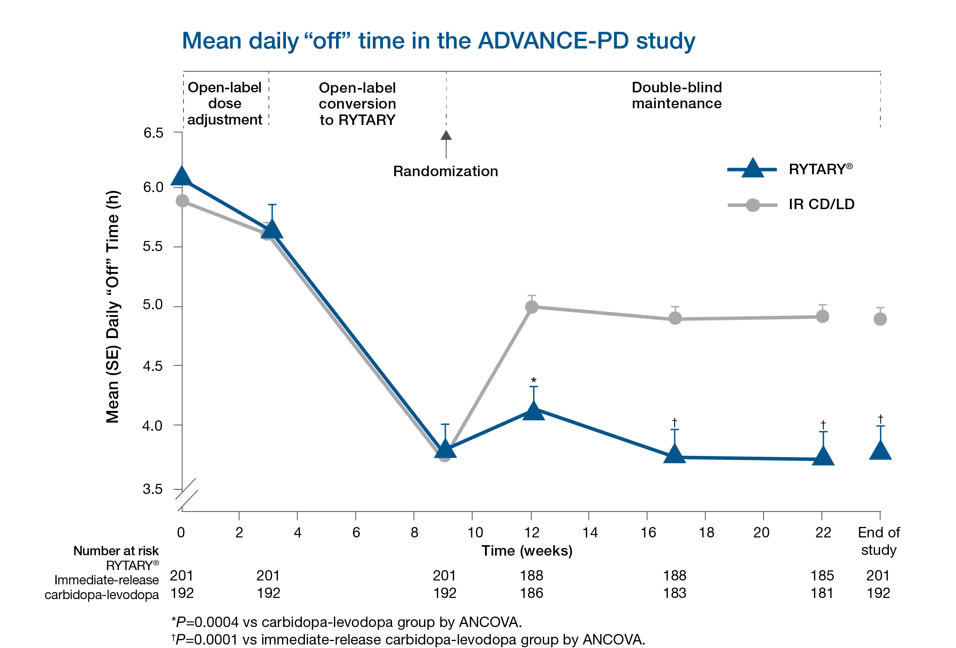

As can be seen from this study, RYTARY is an effective treatment that can reduce “off” time in Parkinson’s disease without troublesome dyskinesia. A secondary endpoint of this study also showed that RYTARY can increase “on” time. In my opinion, RYTARY would provide my patient with the most favorable efficacy and safety profile of the available carbidopa/levodopa treatments, and for these reasons, I have prescribed it for my patient.
In light of the foregoing considerations, it is essential that you approve RYTARY for my patient. It is my view that use of other preparations of levodopa will lead to more motor fluctuations, which could result in harm to my patient and a significantly higher cost of care in the future.^{9,10}

Sincerely,
Signature line

REFERENCES
1. RYTARY [package insert]. Bridgewater, NJ: Amneal Specialty, a division of Amneal Pharmaceuticals LLC; 2019. 2. Hauser RA, Hsu A, Kell S, et al; IPX066 ADVANCE-PD investigators. Extended-release carbidopa-levodopa (IPX066) compared with immediate-release carbidopa-levodopa in patients with Parkinson’s disease and motor fluctuations: a phase 3 randomised, double-blind trial. Lancet Neurol. 2013;12(4):346-356. 3. Fahn S, Oakes D, Shoulson I, et al; Parkinson Study Group. Levodopa and the progression of Parkinson’s disease. N Engl J Med. 2004;351(24):2498-2508. 4. Ahlskog JE, Muenter MD. Frequency of levodopa-related dyskinesias and motor fluctuations as estimated from the cumulative literature. Mov Disord. 2001;16(3):448-458. 5. Hsu A, Yao H-M, Gupta S, Modi NB. Comparison of the pharmacokinetics of an oral extended-release capsule formulation of carbidopa-levodopa (IPX066) with immediate-release carbidopa-levodopa (Sinemet®), sustained-release carbidopa-levodopa (Sinemet® CR), and carbidopa-levodopa-entacapone (Stalevo®). J Clin Pharmacol. 2015;55(9):995-1003. 6. Sinemet [package insert]. Whitehouse Station, NJ: Merck Sharp & Dohme Corp., a subsidiary of Merck & Co., Inc.; 2014. 7. Sinemet CR [package insert]. Whitehouse Station, NJ: Merck Sharp & Dohme Corp., a subsidiary of Merck & Co., Inc.; 2018. 8. Stalevo [package insert]. East Hanover, NJ: Novartis Pharmaceuticals Corporation; 2019. 9. Arnold RJG, Layton A, Rustay NR, Chen S. Cost-effectiveness of extended-release carbidopa-levodopa for advanced Parkinson’s disease. Am J Pharm Benefits. 2017;9(1):23-29. 10. Findley LJ, Wood E, Lowin J, et al. The economic burden of advanced Parkinson’s disease: an analysis of a UK patient dataset. J Med Econ. 2011;14(1):130-139.

PP-HCP-RYT-US-0109 05/2020

